GOWERTON COMMUNITY COUNCIL
CYNGOR CYMUNEDOL TREGŴYR

Minutes of the Ordinary Meeting of Council

Held at St Johns Church Hall at 7.30pm

on Wednesday 3 June 2026

PRESENT:

Councillors:

Ros Holt (Chair), Barbara Small (vice Chair), Wayne Erasmus, Kath Jennings, Amanda Guard, Matt Palmer, Susan Jones, Lynne Carey, June Merrells, Dai Jenkins

Clerk to the Council: Allison James

25. Apologies for absence – Patricia Evans Gareth Evans. Lyneth Howells

26. Disclosures of Personal & Prejudicial – Cllr Lynne Carey declared a Personal and Prejudicial interest in agenda item no 10 Cllrs Dai Jenkins, Barbara Small, June Merrells, Amanda Guard and Katherine Jennings declared a person interest in the same agenda item.

27. Minutes of Council

Resolved that the Minutes of the Council Meeting held on the following date be approved and signed as a correct record.

- Wednesday 13 May 2026

Proposed as correct by Cllr B Small, Seconded by Cllr K Jennings.

28. Announcements of the Chair of Council

Congratulations to Sue who is now Deputy Lord Mayor.
Attended village fun meeting last week – had lottery funding for another years activities - £15k.
Agenda item for next meeting – Chain insurance and assets register update.
Councillors thanked Clerk for completing the audit.

29 Public Question Time

A member of the public requested to speak about agenda item 10. This item was brought forward. Cllr Lynne Carey left the room during the discussion as she had declared a person and prejudicial interest. The resident said he installed the cameras due to anti social behaviour near his house. He brought up various concerns regarding the con club.
Clerk has sought advice and advised Council that The Con Club and the Resident contact the relevant authorities regarding their issues as it is outside of Community Council’s remit.
The resident agreed with the decision.

Resolved – no further action by Community Council is necessary. Cllr Carey entered the room when the discussion was over.

30 Record of Payments including checking and signing of AGAR for 25-26.
Gowerton Community Council - Cash book 26-27
Creditor | Subject | Net | VAT | Total
HP Instant Ink | May Ink | 11.24 | 2.25 | 13.49
SLCC | Membership | 215 | 0 | 215
Clerk | Phone/Dongle May | 38.99 | 0 | 38.99
Audit Wales | 24-25 audit fees | 200 | 0 | 200
Bay Landscapes Ltd | April Invoice | 220 | 44 | 264

The records for 25-26 were checked, the report from the internal auditor was read out and the AGAR was signed by the Chair. The file has been sent to Audit Wales.

31 Correspondence The actions / comments made as in relation to the correspondence reported:

Emails from Dean Mason giving updates regarding Village Fun Events for 2026.
Emails from Swansea Council giving details of planning applications.
Emails from One Voice Wales giving details of training courses, webinars and other news which are forwarded on to Councillors as applicable.

Updates and footage on the Whats App group from Laser Promotions.

An email from a resident in relation to the security cameras discussed at the May meeting.

An email from a local resident who’s wall has been bumped again when customers are parking for the Pharmacy on Elba Street.

Emails from Vision ICT regarding .gov.uk email addresses.

32 Planning Applications & Planning Matters

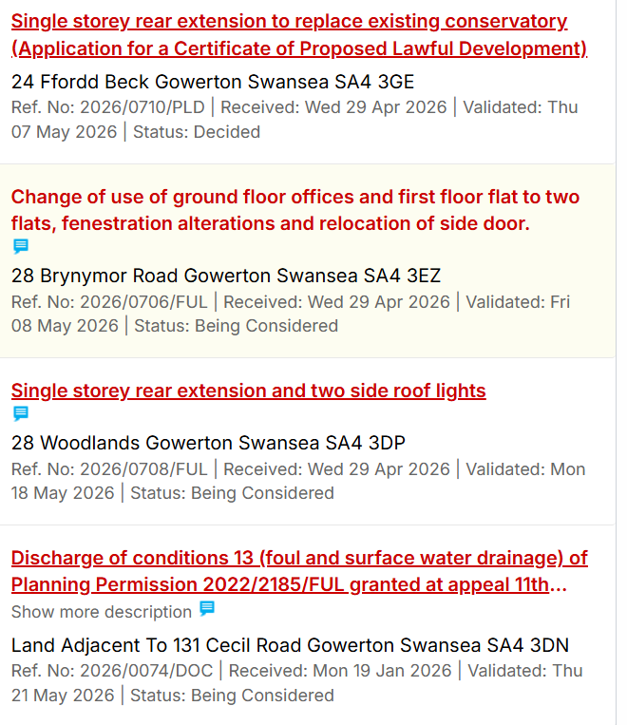

No objections were raiaed.

33 Gowerton Ward Councillors Update

Cllr Susan Jones gave a verbal report of meetings, issues and events attended during the month of May.

Cllr Dai Jenkins submitted a written report of meetings, issues and events attended during the month of May.
34 Cameras on Sterry Road/Con Club
See Minute ref 29. No further action.
Approved.

35. Damaged wall on Elba Street opposite Pharmacy (Cllr W Erasmus)

Email from resident expressing concern about his wall being damaged by a customer at the Pharmacy.

Cllr Susan Jones has contacted Highways to find out what can be done to prevent this happening again. She was advised that possibly yellow lines could be painted there?

35 Proposed Development at Fairwood Terrace

No further updates. Will remain as an agenda item.

36 Events 2026

No further updates on the laser light show. Residents have requested that flowers be placed at the end of the village near Bryn y Mor Road.

Clerk has contacted Swansea Council Parks Dept. Alan Hughes emailed to say there is a spare 3 tier display which can be placed there.

The triangle of land was discussed and Cllr June Merrells said that it might be a nice project for Hive members to work on under the guidance of Mrs Viv Davies who kindly maintains the land on a voluntary basis for which we extend our thanks to her.
Clerk to email Mrs Davies to put the suggestion forward.

37. Email addresses

Clerk asked whether .gov email addresses were required for ward members as they already have them? It was agreed that only 11 email addresses need to be set up rather than 13.

38 Set date and Venue for next meeting.

Date of next meeting – 7.30pm Wednesday 1 July 2026.

Meeting closed at 20:38

Signed________________________________________________ (Chairperson)

Date _____________________________________

