GOWERTON COMMUNITY COUNCIL
CYNGOR CYMUNEDOL TREGŴYR

Minutes of the Ordinary Meeting of Council

Held at St Johns Church Hall at 7.30pm

on Wednesday 2 September 2026

PRESENT:

Councillors:

Ros Holt (Chair), Barbara Small (vice Chair), Katherine Jennings, Matt Palmer, June Merrells,

Clerk to the Council: Allison James

51. Apologies for absence – Cllrs Gareth Evans, Dai Jenkins, Wayne Erasmus, Lyneth Howells, Susan Jones, Lynne Carey, Amanda Guard

Absence without apologies - Cllr Patricia Evans

52. Disclosures of Personal & Prejudicial interests – None declared.

53. Minutes of Council

Resolved that the Minutes of the Council Meeting held on the following date be approved and signed as a correct record.

- Wednesday 1 July 2026

Proposed as correct by Cllr B Small, Seconded by Cllr J Merrells.

55. Announcements of the Chair of Council

Attended meetings for Village Fund.

Events attended:

5 July – Songs of Praise held in Gowerton Comprehensive School.

30 August – 6 a side cricket tournament held at the Athletic ground.

Event at Gowerton Solar Park. The solar company have set up a substantial fund to manage grants for local projects and enterprises.

56 Public Question Time

None

57 Record of Payments

29/06/2026 | St Johns Church | Hall hire April | 25 | 0 | 25
29/06/2026 | St Johns Church | Hall Hire May | 25 | 0 | 25
29/06/2026 | St Johns Church | Hall Hire June | 25 | 0 | 25
29/06/2026 | St Johns Church | Hall Hire July | 25 | 0 | 25
29/06/2026 | NEST | June Pension |  | 0 | 97.82
02/07/2026 | HP Instant Ink | July Ink | 11.24 | 2.25 | 13.49
07/07/2026 | Amazon | Gavel | 6.66 | 1.33 | 7.99
07/07/2026 | HMRC | VAT refund | -2053.35 | 0 | -2053.35
17/07/2026 | Clerk | Phone/Dongle July | 38.99 | 0 | 38.99
21/07/2026 | Moneysoft | Payroll software | 95 | 19 | 114
22/07/2026 | Gowerton CC reserves ac | Transfer VAT return | 2053.35 | 0 | 2053.35
24/07/2026 | HMRC | Months 2 and 3 | 468.51 | 0 | 468.51
25/07/2026 | Clerk | Salary July |  | 0 | 1034.18
03/08/2026 | HP Instant Ink | Aug Ink | 11.24 | 2.25 | 13.49
17/08/2026 | Clerk | Phone/Dongle August | 38.99 | 0 | 38.99
18/08/2026 | NEST | Pension July |  | 0 | 97.82
18/08/2026 | Audit Wales | 24-25 Audit bill | 203.35 | 0 | 203.35
18/08/2026 | Bay Landscapes Ltd | June maintenance | 220 | 44 | 264
18/08/2026 | Bay Landscapes Ltd | July maintenance | 220 | 44 | 264
25/08/2026 | Clerk | August Salary |  | 0 | 1033.98
25/08/2026 | Nest | August Pension |  | 0 | 97.82
25/08/2026 | HMRC | Month 4 | 306.88 | 0 | 306.88

Forthcoming payments for authorisation
Bay Landscape August maintenance
Clerk Salary September
HMRC Month September
Nest Pension September
Church Hall Rent for September
HP Instant Ink Month of September
Vision ICT £114

58 Correspondence
Emails from Dean Mason giving updates regarding Village Fun Events for 2026.

Emails from Swansea Council giving details of planning applications.

Emails from One Voice Wales giving details of training courses, webinars and other news which are forwarded on to Councillors as applicable.

Emails from residents regarding Cllr W Erasmus to which we have replied saying the case is with the Public Ombudsman Wales.

If members of the public have any questions, Community Council have been told to redirect them to the ombudsman.

Emails from the Public Ombudsman Wales regarding Cllr W Erasmus, requesting information.

Email from a resident complaining about motorbikes riding on path on Cecil Road.

Email from Alan Ferris, Swansea Council in reply to request about removing speed bumps on Sterry Road. Will need to be assessed again by Highways Officers.

Form completed for notice of temp event and forwarded to Swansea Council ahead of the Laser Light Show in November.

Fire Risk Assessment and General Safety Assessment have been submitted to Swansea Council for Laser Light Show.

58 Planning Applications & Planning Matters
.
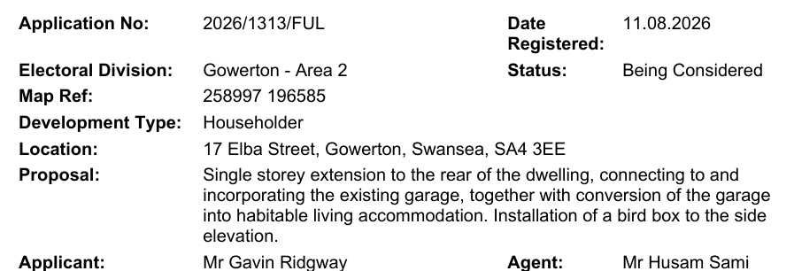

59 Gowerton Ward Councillors Update

Cllr Dai Jenkins submitted a written report of meetings, issues and events attended during the month of July/August.
60. Proposed Development at Fairwood Terrace

No further updates to report.

61. Events 2026

Remembrance Service on Wed 11 November at the flagpole.
Clerk to contact the relevant people.

Laser light show – there is a meeting at St Johns Church hall on Wednesday 9 September 2026 at 7pm to discuss the details of the event.

All available Community Councillors are required to help at the laser light show on Monday 2 November 2026. Cllrs KJ, BS, MP,RH have confirmed they can help out. Cllr JM will be working at the RFC on the night of the show but can help out before if need be,

Lord Mayor has confirmed attendance. Clerk to complete form re times etc and send to Lord Mayors PA, after discussion at meeting on 9 September.

Risk assessments have been completed and temp events notice has been submitted to Swansea Council.

62. Gowerton Sewerage Works – discharging sewerage into the river. (Cllr B Small)

Concerns about sewage in nearby river.

Clerk to contact Gowerton Sewage works/NRW to ask how many discharges have been made within the last five years.

Clerk to write to Welsh Water and ask how many discharges into the water annually over the last five years.

63. Committee member for Rechabite Hall (Cllr Dai Jenkins)

Request by Rechabite Hall committee to have representation from Community Council removed.

Resolved: to remove from Standing Orders at the next AGM.

64. Signs for shared paths in Gowerton to remind people to be considerate.

A resident has complained that cyclists speeding along the shared paths making it dangerous.

Resolved: Clerk to contact Swansea Council and ask if they could provide signage along the paths.

65. Review and adopt Vexatious, Persistent and Unreasonable Complaints Policy

Resolved: The policy was agreed and accepted by all present.

66. Overgrown bushes on Victoria Road (Cllr A Guard)

Complaints made that the bushes on Victoria Road are making it unsafe to walk along the pavement.

Resolved: Clerk to contact Swansea Council to notify the farmer.

50 Set date and Venue for next meeting.

Date of next meeting – 7.30pm Wednesday 7 October 2026 at St Johns Church Hall.

Apologies received from Cllr R Holt as she will be away on holiday.

Meeting closed at 20:30

Signed________________________________________________ (Chairperson)

Date _____________________________________

