GOWERTON COMMUNITY COUNCIL
CYNGOR CYMUNEDOL TREGŴYR

Minutes of the Ordinary Meeting of Council

Held at St Johns Church at 7.30pm

on Wednesday 7 October 2026

PRESENT:

Councillors:

Barbara Small (vice Chair), Katherine Jennings, Matt Palmer, June Merrells,
Lynne Carey, Wayne Erasmus (attended via Teams),

Clerk to the Council: Allison James

67. Apologies for absence – Dai Jenkins, Lyneth Howells, Susan Jones, Amanda Guard, Ros Holt (Chair),

68. Disclosures of Personal & Prejudicial interests – None declared.

69. Minutes of Council

Resolved that the Minutes of the Council Meeting held on the following date be approved and signed as a correct record.

- Wednesday 2 September 2026

Proposed as correct by Cllr J Merrells, Seconded by Cllr K Jennings.

70. Announcements of the Vice Chair of Council

Thanks to Clerk for arranging alternative venue at short notice for this evenings meeting.

Trees cut down in Glanmorfa but two are left there so have taken photos to send to Swansea Council.

71 Public Question Time

None received.

72 Record of Payments

 |  |  |  | 0 | 25
 |  |  |  | 0 | 25
  28/08/2026 | Swansea Council | Precept | -13368.33 | 0 | -13368.33 |  | Receipt
  02/09/2026 | HP Instant Ink | September | 11.24 | 2.25 | 13.49 |  | GE
  14/09/2026 | Vision ICT | Invoice 22286 | 95 | 19 | 114 |  | .gov.uk
  14/09/2026 | Bay Landscapes Ltd | August maintenance | 220 | 44 | 264 |  | GM
  17/09/2026 | Clerk | Phone/Dongle | 38.99 | 0 | 38.99 |  | CE
  18/09/2026 | Swansea Council | Temp Licence Fee | 21 | 0 | 21 |  | E
  25/09/2026 | Swansea Council | Refund of temp licence fee | -21 | 0 | -21 |  | Receipt
Forthcoming payments for authorisation  Bay Landscape September maintenance  HMRC Month 6  Church Hall Rent for September and October  HP Instant Ink Month of October |  |  |  | 0 | 25
 |  |  |  | 0 | 25
Qtr 2 budget report was present and no issues raised.

73 Correspondence
Emails from Dean Mason giving updates regarding Village Fun Events for 2026.
Emails from Swansea Council giving details of planning applications.
Emails from One Voice Wales giving details of training courses, webinars and other news which are forwarded on to Councillors as applicable.

Email from Swansea Council regarding the elections next May giving estimated cost of election.

Email from Audit Wales asking for further information in order to complete the full audit.

Emails sent to Helen Morgan-Rees, Director of Education and Kelly Small, Head of Service, Education inviting them as guests to the Laser Light Show to celebrate 130 years of Gowerton School. Helen Morgan-Rees is unable to attend, unfortunately, but wishes us well for the event.

Email sent to Lord Mayor with details of what is required at the Laser Light show.

Messages sent to Rev Ben Jones, Bethel Chapel and to The Temple Church inviting them to attend the Remembrance Service on 11 November and to give a short service.

Spoken to Jamie Cook from Royal British Legion. Someone will be playing the Bugle at the Remembrance Service and some veterans might attend also.

Emails to Swansea Council giving notice of event on 2 November. Clerk to attend Safety meeting online to discuss.

74 Planning Applications & Planning Matters
.

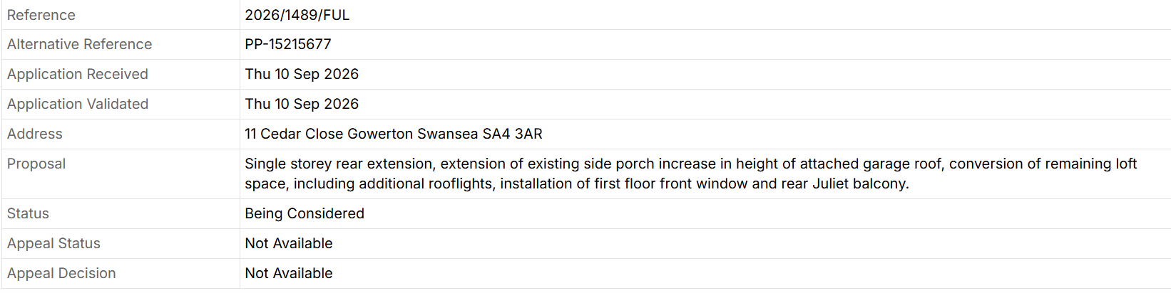

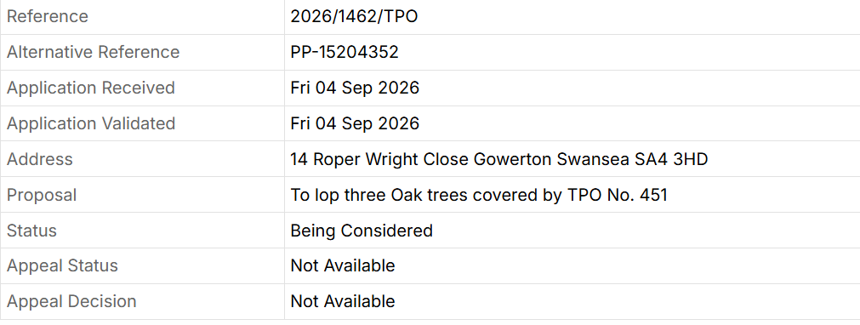

No objections were made.

75 Gowerton Ward Councillors Update

Cllr Dai Jenkins submitted a written report of meetings, issues and events attended during the month of September.
76. Proposed Development at Fairwood Terrace

No further updates to report.

77. Events 2026

Laser light show (approve costs for book tokens - £40. Hire of portaloos approx.£250-300)

Resolved – both costs were agreed. Clerk to purchase book tokens from Waterstones Book Store.

Lord Mayor has confirmed attendance. Clerk to complete form re times etc and send to Lord Mayors PA, after discussion at meeting on 9 September.

Risk assessments have been completed, and temp events notice has been submitted to Swansea Council.

Clerk to attend a meeting with Swansea Safety Advisory Group on 13 October 2026.

Village Fun Committee meeting on Wednesday 14 October 2026 at 7.30pm in St Johns Church Hall.

Remembrance Day Service.

To be held on 11 November 2026. Meet at 10.15am. Rev Ben Jones will be holding a short service. Bugle player will be attending to play the last post. Arranged by Jamie Cook from Royal British Legion. Many thanks to them.

78. Gowerton Sewerage Works – discharging sewerage into the river. (Cllr B Small)

Concerns about sewage in nearby river.

Clerk to contact Gowerton Sewage works/NRW to ask how many discharges have been made within the last five years.

Clerk to write to Welsh Water and ask how many discharges into the water annually over the last five years.

Ongoing – difficult to find a contact online without giving an address. Clerk to write an actual letter to Welsh Water rather than email.

79. Offer of Conifer Tree from Resident (Cllr Dai Jenkins)

A local resident had offered to donate a tree for the centre of the village from his garden.

Resolved – the cost of transporting the tree, erecting on the green and disposing of afterwards as there were no roots, was deemed as not cost effective. Therefore, we would have to refuse this kind offer on this occasion.

50 Set date and Venue for next meeting.

Date of next meeting – 7.30pm Wednesday 4 November 2026 at St Johns Church Hall.

Meeting closed at 20:18

Signed________________________________________________ (Chairperson)

Date _____________________________________

